Bachelor of Science in Computer Science & Engineering

Intrusion Detection System Using Snort and Python Log Analyzer
Submitted by
Fairooz Nahiyan
ID: C213242
Joinab Binte Siraj Asifa
ID: C213248

Submitted to
Ms. Asmaul Hosna Sadika
Assistant Lecturer, Dept. of CSE
Department of Computer Science & Engineering
International Islamic University Chittagong (IIUC) Chattogram, Bangladesh.

Abstract
In today’s digital landscape, the growing frequency and sophistication of cyberattacks highlight the critical need for effective and accessible network security tools. This project presents a lightweight, signature-based Intrusion Detection System (IDS) that combines the packet inspection capabilities of Snort 3 with the simplicity and flexibility of Python for alert analysis. Snort is configured with custom detection rules to identify common network threats such as ICMP ping sweeps, SSH brute force attempts, port scans, and basic SQL injection patterns. However, raw Snort alerts can be difficult to interpret for beginners and non-technical users. To address this, the project includes a Python-based log analyzer that reads Snort’s alert logs, processes the data, and generates clear, visual summaries of detected intrusions. By integrating detection and analysis in a unified and beginner-friendly environment, this system enhances the accessibility and educational value of intrusion detection. The solution is deployed on Kali Linux, making it suitable for cybersecurity labs, training setups, and small-scale real-world applications. Overall, this project demonstrates a practical, modular, and easily extendable approach to network intrusion detection and alert visualization.

Table of Content

1. Introduction 3
2. Objectives 3
3. Motivation 3
4. Literature Review 4
5.Proposed Methodology 4
6. Project Management 6
7. References 6

- Introduction
1.1 Background of the Project
With the rapid growth of internet usage and digital services, networks have become increasingly vulnerable to unauthorized access, malware, and a variety of sophisticated cyberattacks. Traditional security mechanisms like firewalls and antivirus programs are often not enough to handle modern threats, especially those that exploit zero-day vulnerabilities or target network-level weaknesses. Intrusion Detection Systems (IDS) have emerged as a crucial layer of defense that actively monitors traffic and detects suspicious patterns based on predefined rules or anomalies. Among open-source IDS tools, Snort stands out due to its efficiency, customizability, and strong community support. However, Snort’s raw log output can be overwhelming, particularly for beginners and educational use. This project addresses that gap by combining Snort 3 with a custom-built Python-based log analyzer that simplifies the interpretation of Snort alerts through visualization.
1.2 Importance in Computer Security
Intrusion Detection Systems play a vital role in the early detection and mitigation of security threats. They provide real-time insights into network activities, enabling system administrators to respond to threats before significant damage occurs. A signature-based IDS like Snort excels in detecting known threats with high accuracy by matching packet content against a library of known attack patterns. However, one of the major limitations of traditional IDS systems is the difficulty in analyzing and interpreting large volumes of log data. By integrating Snort with a Python log analyzer, this project makes intrusion detection more user-friendly, interpretable, and practical for educational and small-scale deployment. It promotes awareness and understanding of cybersecurity among students, researchers, and network administrators by making threat data easier to analyze and act upon.
1.3 Objectives
The main objectives of this project are:
- To deploy a Snort 3-based Intrusion Detection System on Kali Linux using custom detection rules for common attacks.
- To detect network intrusions such as ICMP scans, SSH brute force attempts, SQL injections, and DNS queries using Snort signatures.
- To log Snort alerts in a format suitable for external analysis.
- To design and implement a Python log analyzer that reads and visualizes Snort alert logs in a human-readable and informative format.

  - Scope of the Project
Inclusions:
- Installation and configuration of Snort 3 on Kali Linux.
- Writing and testing of custom Snort rules to detect specific attacks.
- Logging alerts using Snort’s alert_fast output format.
- Implementation of a Python-based log analyzer using libraries like re, collections.Counter, and matplotlib.
- Visualization of attack statistics through pie charts and summary data.
- Use of simulation tools like ping, nmap, and curl to generate test traffic.
This project focuses on deploying Snort 3 on the Kali Linux platform, which is a security-focused Debian-based distribution commonly used for penetration testing and cybersecurity research. To enhance the functionality of Snort, this project integrates a Python-based log analyzer that reads Snort alert logs, processes the data, and visualizes the frequency of different types of detected intrusions. This approach not only strengthens detection capabilities but also simplifies monitoring for administrators by providing a graphical summary of network threats.

- Literature Review

Over the past two decades, researchers and practitioners have explored a variety of techniques and tools to detect and analyze network intrusions. Among open-source solutions, Snort has been the most widely adopted for signature-based intrusion detection. It uses predefined rules to identify known threats by matching packet content against attack signatures, making it a reliable solution for detecting common vulnerabilities.

Nitin Verma (2020) in "Detect Network Threat Using SNORT Intrusion Detection System"^{[1]} simulated multiple attack scenarios—such as ping sweeps, port scans, and SQL injections—by creating custom Snort rules. His work successfully demonstrated Snort’s capability to detect these attacks in a lab environment. However, the research was limited to Snort 2.x and did not incorporate any automated log analysis or visualization, leaving alert interpretation entirely manual.

Similarly, Hamed H. Al Ghafri et al. (2017) ^{[2]} at Universiti Teknikal Malaysia Melaka implemented Snort with live traffic analysis and validated its detection capabilities using Wireshark. While their methodology confirmed Snort’s efficiency in real-time monitoring, the approach lacked an integrated tool for summarizing and visualizing alerts, which could have improved usability for non-expert users.

R. Gaddam and Dr. M. Nandhini (2017^{) [3]} investigated Snort’s utility in cybersecurity education, deploying it on Kali Linux to teach rule-writing and network monitoring. While the educational

application was significant, the system relied heavily on raw logs and lacked features to assist in quickly identifying trends in network attacks.

A more recent study by Nađa Gavrilović et al. (2022^{) [4]} introduced a visualization interface for Snort alerts using Angular and Node.js. This approach enhanced the readability of Snort alerts but required a full-stack setup, which can be overly complex for small-scale or academic projects. Moreover, their solution did not aim for a lightweight, easily deployable analysis system.
  - Gaps Identified:
From these studies, it is clear that while Snort is highly capable in detecting known threats, there is a lack of lightweight, beginner-friendly analysis tools that can process Snort logs into clear, actionable insights. Most existing research either focuses solely on detection or integrates heavy, enterprise-level visualization tools unsuitable for smaller setups. Additionally, the migration to Snort 3, which offers improved modularity and performance, is still not widely reflected in academic projects.
  - Contribution of This Project
This project addresses these gaps by deploying Snort 3 on Kali Linux with a set of custom detection rules for common attacks and integrating a Python-based log analyzer. The analyzer parses Snort’s alert.fast output and presents summarized visual data using simple charts, making it accessible to both beginners and educational users without the need for a complex setup. This combination of effective detection and lightweight visualization bridges the gap between raw IDS output and actionable network security insights.

- System Analysis

  - Problem Statement
In modern network environments, the volume and complexity of cyber threats are increasing rapidly. While open-source tools like Snort offer robust intrusion detection capabilities through signature-based rules, their raw log outputs are often cryptic and challenging for beginners or non-technical users to interpret. Many existing systems lack an integrated, lightweight, and user-friendly analysis tool that can summarize and visualize detected threats without requiring enterprise-level infrastructure. As a result, network administrators and students often face difficulties in identifying patterns or prioritizing responses based solely on Snort’s textual alerts. This creates a gap for a modular, beginner-friendly solution that combines real-time detection with simple and clear visualization of intrusion data.

  - Requirements
Functional Requirements

- Intrusion Detection:
- The system must monitor network traffic in real time using Snort 3.
- It must detect common attacks including ICMP ping sweeps, port scans, SSH brute force attempts, SQL injections, and DNS queries.
- Rule Management:
- Allow addition, modification, and deletion of custom Snort rules in the local.rules file.
- Logging:
- Snort must log all detected events to a specific directory (e.g., /var/log/snort/alert.fast) for further processing.
- Log Analysis:
- A Python-based analyzer must read the Snort log file and extract key alert details such as timestamp, source/destination IP, and message.
- Visualization:
- The analyzer must generate graphical summaries (e.g., pie charts, bar charts) showing the distribution of different types of attacks.
- Test Traffic Simulation:
- The system must be tested using tools like ping, nmap, and curl to simulate attack patterns and verify detection.
  - Risk Analysis

- Possible Threats to the System:
- False Negatives: Attacks that are not detected because they do not match any existing signature.
- False Positives: Legitimate traffic incorrectly flagged as malicious, potentially causing unnecessary alerts.
- Signature Obsolescence: Outdated rules may fail to detect new or evolving threats.
- Possible Vulnerabilities in the System:
- Rule Misconfiguration: Poorly written rules may generate excessive alerts or miss threats.
- Log Tampering: If log files are not properly secured, attackers could alter them to hide evidence.
- Resource Exhaustion: High traffic volumes may cause Snort to consume excessive CPU/memory resources, affecting system performance.
- Mitigation Strategies:
- Regularly update Snort rules to include the latest signatures.
- Implement strict file permissions for /etc/snort/rules and /var/log/snort.
- Use detection filters to reduce false positives by controlling alert thresholds.
- Monitor system resource usage and optimize rule sets to avoid performance bottlenecks.

- Methodology

  - Approach
This project adopts a signature-based intrusion detection approach using Snort 3 as the detection engine and Python as the log analysis tool.
- Detection Layer: Snort inspects incoming and outgoing packets, comparing them against predefined rules (signatures) to identify malicious activity.
- Analysis Layer: Once an alert is generated, it is logged in a structured format (alert.fast). The Python log analyzer reads these logs, extracts essential details, and visualizes attack patterns.
- Testing Layer: Simulated network traffic (e.g., ICMP pings, SYN scans, SSH brute force attempts) is generated to validate the IDS functionality.
While the project focuses on intrusion detection and alert visualization, it does not implement intrusion prevention (i.e., blocking traffic). No cryptographic or authentication mechanisms are implemented because the system operates in a monitoring capacity, not as a secure communication protocol.

  - System Architecture Diagram
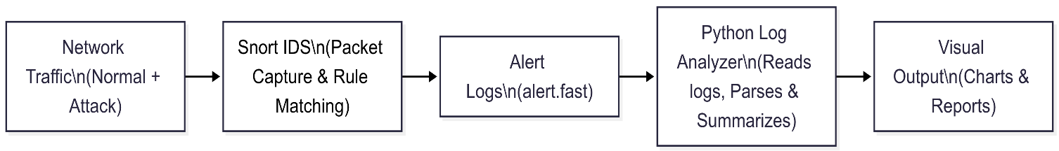
Figure 01 : System Architecture Diagram
  - Dat Flow Diagram
- DFD level-0 (Context level)
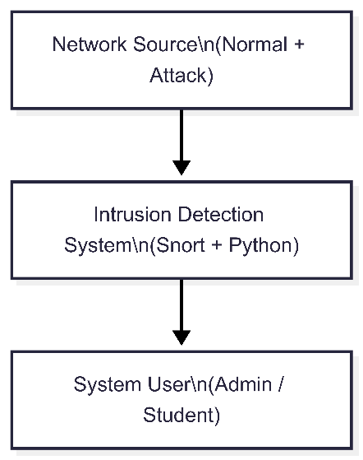
Figure 02 : DFD level-0

- DFD level-1
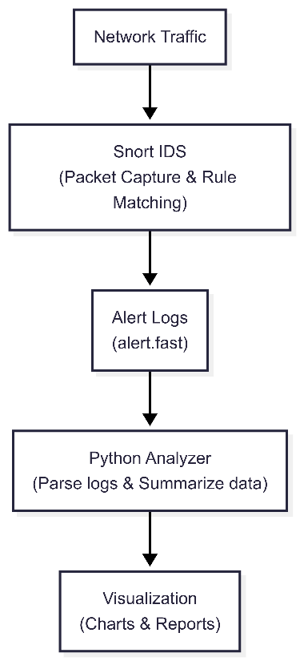
Figure 03 : DFD level-1
- DFD Level 2
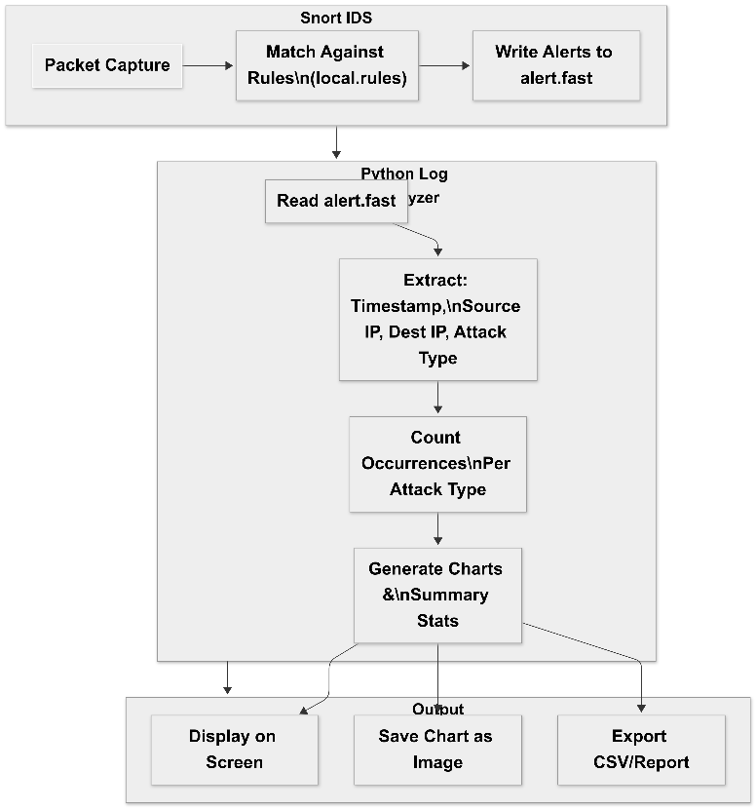
Figure 04 : DFD level-2

  - Algorithm

- Snort Detection Pseudo :
START
Initialize Snort with configuration file (snort.lua)
Load HOME_NET and EXTERNAL_NET variables
Load local.rules containing detection signatures
FOR each incoming packet:
Compare packet headers and payload with Snort rules
IF match found:
Generate alert with timestamp, source IP, destination IP, and rule message
Save alert in /var/log/snort/alert.fast
END FOR
STOP
- Python Log Analyzer
START
Set log_file_path = "/var/log/snort/alert.fast"
Open log_file_path for reading
Initialize attack_count = empty dictionary

FOR each line in log file:
Extract timestamp, attack type, source IP, destination IP
Increment count for the attack type in attack_count

Display attack_count in terminal
Plot pie chart of attack types using matplotlib
Save pie chart as image file
STOP

- Implementation

  - Languages, Tools, and Frameworks Used
The development and testing of the Snort-based Intrusion Detection System on Kali Linux involved a combination of programming, scripting, and visualization tools. The implementation stack is outlined below:
- Operating System: Kali Linux (Debian-based, penetration testing optimized)
- Intrusion Detection System: Snort 3.9.1.0
- Programming Language: Python 3.13.5
- Libraries Used:
- re, os, json: For parsing and handling Snort alert logs
- matplotlib, seaborn, pandas: For generating visual reports
- Visualization Framework: Mermaid.js (for flowchart and system diagram representation)
- Packet Capture Tool: tcpdump (used alongside Snort for monitoring real-time traffic)
- Shell Scripting: Bash for Snort automation
- Graphing Tool: Matplotlib/Seaborn (Python)

  - Output results
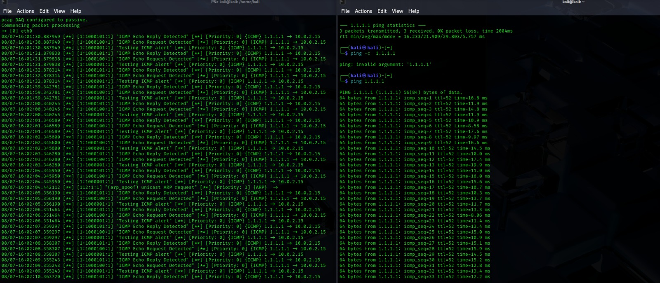
Figure 05 : ICMP alert
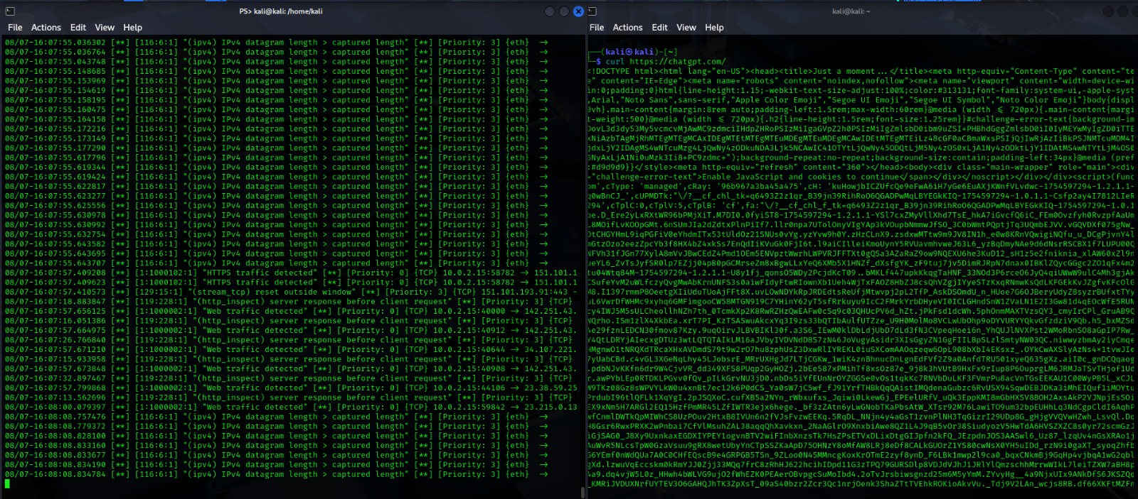
Figure 06 : HTTPS alert
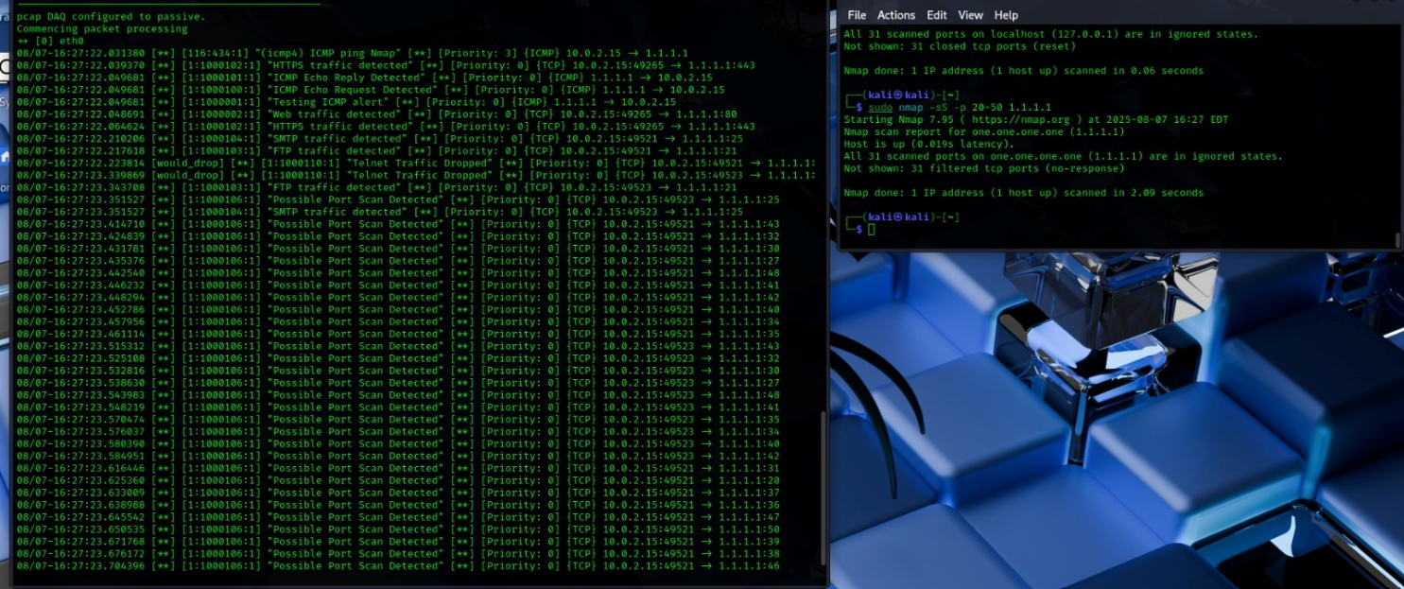
Figure 07 : NMAP alert
  - Code Snippet
- Config file : sudo nano /usr/local/etc/snort/snort.lua
dofile('/usr/local/etc/snort/snort_defaults.lua')

HOME_NET = '192.168.0.0/24'
EXTERNAL_NET = 'any'

ips = {
enable_builtin_rules = false,
rules = [[
include /etc/snort/rules/local.rules
]]
}

logdir = '/var/log/snort'
alert_fast = true

- Rules file : sudo nanao /etc/snort/rules/snort3.rules
# ICMP rules
alert icmp any any -> $HOME_NET any (msg:"Testing ICMP alert"; sid:1000001; rev:1;)
alert icmp any any -> $HOME_NET any (msg:"ICMP Echo Request Detected"; sid:1000100; rev:1;)
alert icmp any any -> $HOME_NET any (msg:"ICMP Echo Reply Detected"; sid:1000101; rev:1;)
# Nmap SYN Scan Detection
alert tcp any any -> any any (msg:"Nmap SYN Scan Detected"; flags:S; detection_filter:track by_src, count 10, seconds 5; sid:1000002; rev:1;)
# TCP rules
alert tcp any any -> any 80 (msg:"Web traffic detected"; sid:1000002; rev:1;)
alert tcp any any -> any 443 (msg:"HTTPS traffic detected"; sid:1000102; rev:1;)
alert tcp any any -> any 21 (msg:"FTP traffic detected"; sid:1000103; rev:1;)
alert tcp any any -> any 25 (msg:"SMTP traffic detected"; sid:1000104; rev:1;)
# SSH Brute Force detection
alert tcp any any -> any 22 (msg:"SSH Brute Force Detected"; flow:to_server,established; detection_filter:track by_sr>
# Port scan detection (SYN scan)
alert tcp any any -> any any (msg:"Possible Port Scan Detected"; flags:S; detection_filter:track by_src,count 20,seco>
# SQL Injection detection (simple pattern)
alert tcp any any -> any any (msg:"SQL Injection Attempt Detected"; pcre:"/(?i)' OR 1=1/"; sid:1000107; rev:1;)
# DNS Query detection
alert udp any any -> any 53 (msg:"DNS Query Detected"; sid:1000108; rev:1;)
# SMB traffic detection (Windows file sharing)
alert tcp any any -> any 445 (msg:"SMB Traffic Detected"; sid:1000109; rev:1;)
# Drop Telnet traffic
drop tcp any any -> any 23 (msg:"Telnet Traffic Dropped"; sid:1000110; rev:1;)

- Python log analyzer : sudo nano snort_log_analyzer.py
import matplotlib.pyplot as plt
from collections import Counter
import re

# Replace with your actual Snort alert log file path
log_file_path = '/var/log/snort/alert.fast'

def parse_alerts(file_path):
alert_types = []
with open(file_path, 'r') as file:
for line in file:
match = re.search(r'\[\d+:\d+:\d+\] (.+?) \[', line)
if match:
alert_types.append(match.group(1))
return alert_types

def visualize_alerts(alert_list):
counter = Counter(alert_list)
labels = list(counter.keys())
sizes = list(counter.values())

plt.figure(figsize=(10, 8))
plt.pie(sizes, labels=labels, autopct='%1.1f%%', startangle=140)
plt.title("Snort Alert Types (Pie Chart)")
plt.axis('equal')
plt.show()

alerts = parse_alerts(log_file_path)
visualize_alerts(alerts)

- Testing & Results
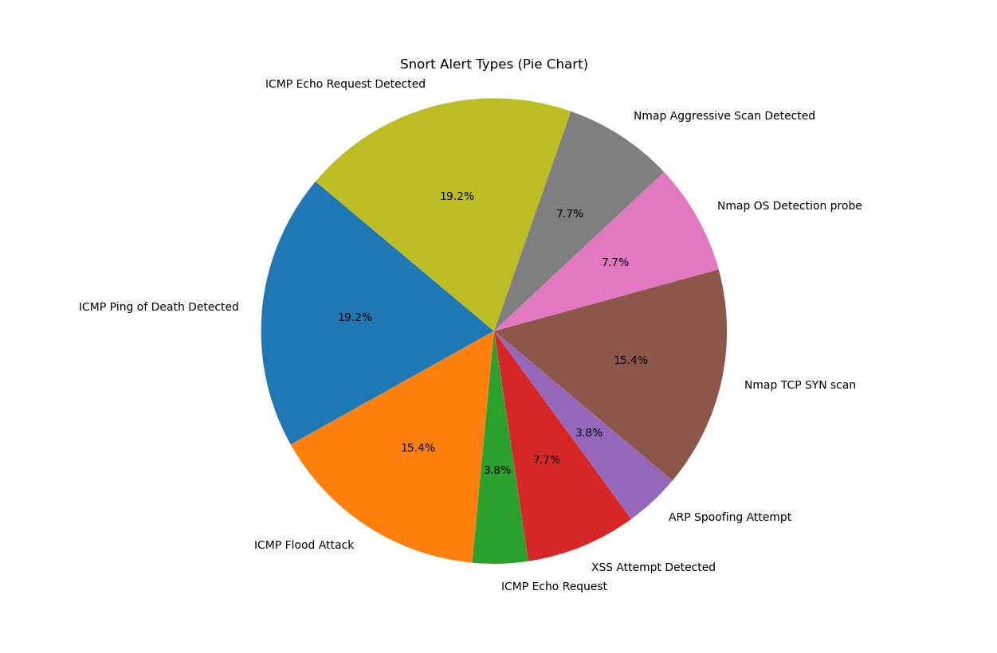
Figure 08 : Python Analyze of rules alerts

- Conclusion and Future work

- References
[1] N. Verma, “Detect Network Threat Using SNORT Intrusion Detection System,” Department of Information Technology, USICT, Guru Gobind Singh Indraprastha University, Delhi, India, 2020.
[2] H. H. Al Ghafri, Z. Z. Abidin, K. Kurbonov and R. Yusof, “Implementation of Intrusion Detection System using Snort,” Centre for Advanced Computing Technology, Faculty of Information and Communication Technology, Universiti Teknikal Malaysia Melaka, Malaysia, 2017.
[3] R. Gaddam and M. Nandhini, “An Analysis of Various Snort Based Techniques to Detect and Prevent Intrusions in Networks,” in Proc. Int. Conf. on Intelligent Computing and Control Systems (ICICCT), 2017.
[4] N. Gavrilović, V. Ćirić and N. Lozo, “Snort IDS System Visualization Interface for Alert Analysis,” Serbian Journal of Electrical Engineering, vol. 19, no. 1, pp. 67–78, Feb. 2022.

